**Organizational Aspect**

Aloe Vera Delight Candy Co. operates as a single proprietorship, owned and managed by one person. This setup is common in manufacturing, especially in confectionery. Advantages include low startup and dissolution costs, but the owner is personally liable for any failures. Decision-making power and profits belong solely to the owner. However, limited business expertise may hinder efficiency, and entrusting tasks to others carries some risk. Success relies on effectively utilizing skilled personnel.

**Manpower and Technical Staff Requirements**

Aloe Vera Candy Manufacturing will operate with a team of four (4) employees, following a flat organizational structure. Each employee will receive compensation based on their position, qualifications, and duties within the organization. The proposed roles and manpower requirements are as follows:

1. Cahier

2. Pastry chef

3. Maintenance staff (2)

This structured system ensures smooth operations and clear responsibilities at the Aloe Vera Candy Manufacturing. All employees must have the required health certifications mandated by the government. We also bring in trainees from local schools and universities, but they need to have their health certificates before working in the facility.

**Pre-Operation Phase**

During the pre-operational phase of setting up the Aloe Vera Candy Manufacturing business, three key personnel play crucial roles. The owner charts the course for the business. They define the company's mission, values, and overall goals.They make key decisions about the business strategy, such as what products or services to offer, who the target market is, and how to compete.The Managers play a vital role at all levels of business, not just small businesses.Managers set the tone and culture for their teams. They motivate employees, delegate tasks effectively, and provide constructive feedback to help them improve and reach their goals. The Financial Consultant assists in financial planning, budgeting, and forecasting, ensuring that all financial operations comply with legal and regulatory requirements.

**Operation Phase**

In the operational phase, the owner/manager of the Aloe Vera Candy Manufacturing facility will play a hands-on role in supervising production activities and ensuring product quality. Operational managers constantly analyze and improve workflows to maximize efficiency and productivity. They identify bottlenecks, streamline processes, and implement new technologies to get things done faster and better.The sales and marketing manager creates comprehensive plans for both sales and marketing activities. This involves defining target markets, setting sales goals, and developing marketing campaigns that generate qualified leads for the sales team.

**Duties and Functions of Key Management Team**

The owner assumes the role of strategic coordinator during the pre-operational phase, overseeing all aspects of setup and planning. In normal operations, a competent manager leads day-to-day activities, supported by the administrative assistant for office-related matters. Their responsibilities encompass procurement organization, ensuring inventory accuracy, and validating material reports.

Reporting directly to the manager, the Production Manager and Quality Control Supervisor monitor departmental progress, ensuring alignment with company objectives to deliver top-quality products.

**Figure 1. Pre-Operational Chart**

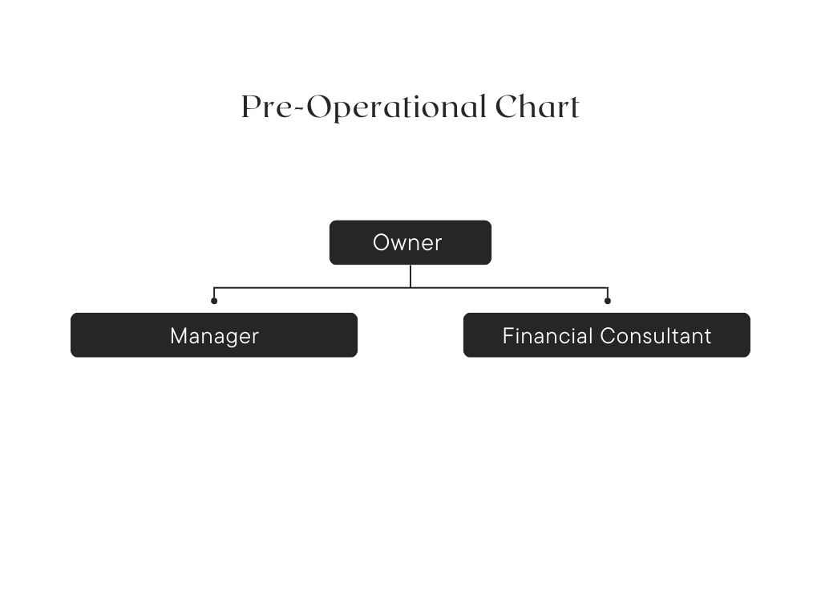

**Figure 2.** **Organizational chart**

**Aloe Vera Delight Candy Manufacturing Organizational Chart**

**Salaries, Wages and Benefits**

Salary packages that the establishment will offer its employees shall also include the cost of insurances such as SSS, Phil health and PAG-IBIG. The establishment shall also provide the 13th month pay and the leave benefits.

Will be paid according to the level in the organization and the qualification as well as duties and responsibilities. Starting salary for lower-level management

|  |  |  |  |
| --- | --- | --- | --- |
| Salaries | Annual Salary (Year 1) | Annual Salary (Year 2) | Annual Salary (Year 3) |
| Cashier | ₱120,000.00 | ₱120,000.00 | ₱120,000.00 |
| Pastry Chef | ₱240,000.00 | ₱240,000.00 | ₱240,000.00 |
| Maintenance Staff | ₱108,000.00 | ₱108,000.00 | ₱108,000.00 |

**Recruitment and Staffing Process**

The candy shop will hire four employees, comprising a Cashier, Pastry Chef, and two Maintenance Staff. The Pastry Chef will be hired by the owner/manager through recommendations from culinary schools and industry professionals.

The Cashier and Maintenance Staff will be sourced through a combination of methods, including job placement offices at technical schools and vocational training centers, online job portals, and local advertisements.

Shortlisted candidates will undergo a screening process conducted by department heads to assess their skills and suitability for the roles. Walk-in applicants, if any, will also be considered and shortlisted by the relevant department heads.

The Cashier and Maintenance Staff will be interviewed by the owner/manager to ensure alignment with the shop's vision, values, and objectives. Final interviews for all positions will be conducted by the owner/manager to ensure compatibility with the shop's culture and requirements.

**Project timetable** (GANTT CHART)

|  |  |  |  |  |  |  |  |
| --- | --- | --- | --- | --- | --- | --- | --- |
|  | Jan. Feb | March April | May June | July Aug | Sept Oct | November | Dec |
| Inspection of the building & changes |  |  |  |  |  |  |  |
| Hire Staff |  |  |  |  |  |  |  |
| Canvas and Acquisition of machineries and equipment |  |  |  |  |  |  |  |
| Training of staff |  |  |  |  |  |  |  |
| Start of operation with soft opening |  |  |  |  |  |  |  |
| Full operation |  |  |  |  |  |  |  |